# **Don't Look at Me**

### Self-Evaluation

Zoe's avatar

[Zoe](https://substack.com/@zoeffc)

May 09, 2025

1

[2](https://femmefuturescooperative.substack.com/p/dont-look-at-me/comments)

1

Share

Hi guys!

I just submitted my end-of-fiscal-year self-evaluation to my boss. Honestly, I hate writing these because it requires a very specific type of introspection. Unlike when I naval-gaze here, that naval-gazing is going to the person who will, in turn, tell me if I am meeting the expectations of my job and earning my paycheck. It’s different.

I wanted to talk about this process from my experience and maybe provide some guidance and insight for folks navigating these in the early stages of their careers.

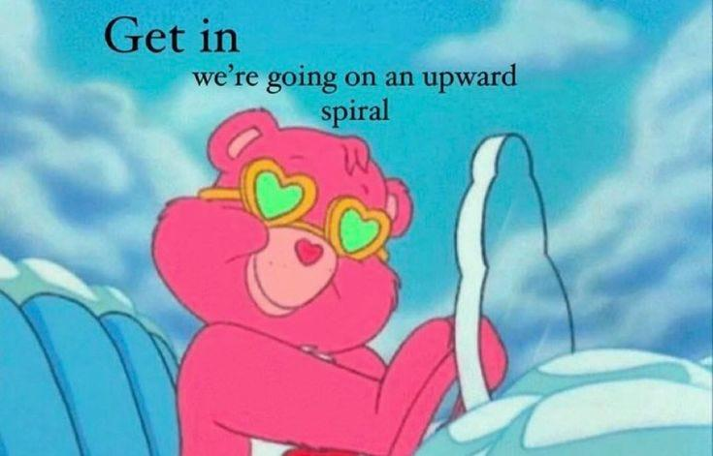

Before I go any further — let’s do the housekeeping.

First, if you are not already a subscriber and you resonate with any of the following descriptors, consider joining the cooperative: (1) Early-career professional; (2) Feminist; (3) Do-gooder; (4) Former Gifted Kid; (5) Overachiever; or (6) Capitalism-hater.

Subscribed

Second, if you like what I am saying and it makes you think of someone in your family/office/friend group, send it their way.

[Share Femme Futures Cooperative](https://femmefuturescooperative.substack.com/?utm_source=substack&utm_medium=email&utm_content=share&action=share)

Third, I say some personal and vulnerable shit every week. Say some vulnerable shit back. It’s called a community.

[Leave a comment](https://femmefuturescooperative.substack.com/p/dont-look-at-me/comments)

Okay — back to it.

Regular review processes are fairly par for the course at most workplaces. At my first job post-grad, we all did them around our work anniversary. At my current organization, everyone does them before the close of the fiscal year on June 30th and at the end of the calendar year.

My organization sends out worksheets that all of us are expected to fill out and return to our managers. Each time I receive this worksheet and am confronted with what sometimes feels like a demand to prove my worth, I falter. This shit is emotionally tough. I don’t know if it is my own trauma that whispers in my ear that identifying points for growth will give my manager something to use against me, or if everyone feels that, but it is there.

A few months back, when I was doing my mid-year self-evaluation, I was so anxious that I ended up going to one of my work friends to ask for help. She knows everything, and so I figured she would know about this. She totally did.

What she told me felt revolutionary and is the main reason I felt okay-ish completing my end-of-year review this time. She told me that *all these are for is to help identify your goals for the coming year*.

Goals?! Now that is something I can do. I am constantly setting goals for myself.

She told me that *good managers want to help you set these goals and they want to know where your head is at so that they can help you achieve those aspirations.*

Fantastic, because I could really use some guidance on where I am going in my career, where I want to be going, and how I should be going about getting there. Also I suck at SMART goals, so if someone can give me some guidance there, that would be great. What a relief.

Here’s the thing: there are actually very few good managers. Now, obviously, “not good” does not mean “bad”. It is a spectrum. Some managers are not people-oriented and lack the amount of empathy needed to help someone else articulate their goals. Other managers have never received good management themselves, so have no idea what it might look like. Some managers are bullies. While I really hope that you have a good manager who is excited to see you grow, I want to share some tips on dealing with not-so-good managers.

As you already know, I have faced some challenging workplace dynamics in my few short years in the workforce. I will be the first to tell you that, yes, your annual review *can* go poorly. However, if it does, it hopefully should not be a surprise.

By the time that review rolls around, you should know where you stand with your manager. You will know if you trend towards their favorable side or the other side. If you are nervous about your review because you don’t know which way your manager will swing, prepare for the worst. I do mean “prepare” as well. I want you to go in with examples of your work wins, times where they could not have completed a project without you, and with an attitude of calm collection. Your managers are people and they can be awful. The best way to deal with awful people who are in charge of you is to stay grounded.

Unfortunately, even if you prepare, you may still walk away feeling like you make everyone’s lives harder, are incapable of learning, and are a liability. I have left a few reviews feeling like this. Here are some things that I want you to remember if that happens:

1. You are innately good and do not deserve to be spoken to unkindly — even if you have made mistakes, even if this job is really not your thing.
2. No one is incapable of learning. You are learning. The environment might not be right for you to learn to your best ability (and that might be because you are being bullied by team).
3. It is okay to make mistakes. Yes, they suck, and yes, you have to be able to deal with the consequences, but you are learning and unfortunately, you will make mistakes. You will also make more mistakes if you are stressed, which comes with being in a toxic environment.
4. You are more than your professional self. You are a human who provides so much beauty and value to this world through your relationships, your art, your vision, and your words. Someone can be critical of you as a worker without it diminishing your value as a human.

If you are in a situation where the above tips feel relevant, I urge you to look for other jobs. You deserve to be supported in your career by the people who you work with everyday.

To everyone, good luck with annual reviews if they are on your horizon. You are amazing.

Best,

Zoe

